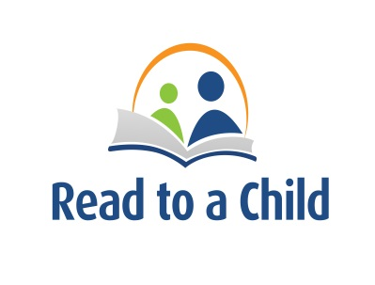
Los Angeles for Literacy

July 17th, 2014 | 6:00 PM - 9:00 PM
The Ace Hotel
929 S. Broadway | Los Angeles, CA | 90015

Silent Auction Preview

Here’s just a few silent auction packages you don’t want to miss out on July 17th

Culture Vulture
Enjoy the best independent movies at Los Angeles’ premier independent movie theatre while catching up on all the best Los Angeles has to offer. This package includes 6 Admit One passes to Laemmle Theatres, a 1-year subscription to Los Angeles Magazine and its famous restaurant and shopping features, and 2 Admission Passes to the Museum of Contemporary Art (MOCA).

Rest in Your Nest: DIRECTV Package
Staying in with your family after a long day of work? No need to fight over the remote or struggle to find something to watch with this this DIRECTV package of over 200 digital channels and service for up to four receivers. Afraid of missing that one episode? A HD DVR system comes with it! Professional standard home installation and a satellite dish are also included with this 1-year service deal.

Hooray for Hollywood
Experience a bit of Hollywood history with this 2 person package from Miceli’s Restaurants and the Hollywood Bowl. Savor a lovely dinner at Hollywood’s oldest Italian restaurant before attending a concert of your choice at LA’s best outdoor venue. Be sure to take a look at the stars (either from the movies or up in the sky) during your night out!
Football and Fries
Don’t bruin your day by missing out on the chance for you and a friend to see the UCLA Bruins play against the Utah Utes! Treat him or her to In-N-Out after the game to top off your quintessentially Southern California day-win or lose, a Double Double is always a safe bet!

Destination Disney
Head on over to the Disneyland Resort to experience all the park has to offer with a pack of 4 1-Day Park Hopper Tickets that will give you access to both Disneyland and California Adventure. Visit Indiana Jones in Adventure Land, Sleeping Beauty in Fantasyland, and even Lighting McQueen in Cars Land; ride Matterhorn Bobsleds, watch the parade, and have plenty of churros during your day at Disney. Whether you bring friends or your family with you, you’re bound to have a magical day!

And Much More!!
info@readtoachild.org
(310) 348-9991

